“Inventory Management System”

A PROJECT REPORT

Submitted by
Tushit Maisuriya (ET25MTCA097)
Dhruvinsinh Solanki (ET25MTCA130)
Jevil Patel (ET25MTCA106)

Under the Guidance Of
Prof. Veer Pachchigar
In fulfillment for the subject Software Project-1 (MTCA26112) of

Master of Computer Applications
At
Sarvajanik College of Engineering & Technology, Surat


Sarvajanik University, Surat
December, 2025



Sarvajanik Education Society

Sarvajanik College of Engineering & Technology, Surat.
Department of Computer Application
Academic Year 2025-26

Date: 27/12/2025

CERTIFICATE

This is to certify that the project entitled “Inventory Management System” has been Submitted by Tushit Maisuriya (ET25MTCA097), Dhruvinsinh Solanki (ET25MTCA130), Jevil Patel (ET25MTCA106) towards the fulfillment of the subject Software Project-1 (MTCA26112) Master of Computer Applications (M.C.A.) in (1st Semester) of Sarvajanik University, Surat during the academic year 2025-26.

Prof. Veer Pachchigar

(Guide’s Signature)
Dr. Gayatri Kapadia (Head - Department of Computer Apllication)

Examiners’ Signature:

1.

2.

Acknowledgements

Our self Tushit Maisuriya (ET25MTCA097), Dhruvinsinh Solanki (ET25MTCA130), Jevil Patel (ET25MTCA106) Have opportunity to express our knowledge. We would like to express our gratitude to all those who gave us the possibility to complete our project. Success is such a comprehensive project can’t achieve single-handed. so, we would like to express our sincere thanks to all the dignitaries who were involved in making this project the great joy and turning it our into successful piece of work. we also indebted to our Prof. Veer Pachchigar who provided constant encouragement, support & valuable guidance before and during our project. It was her effort who led me to this place for project work. Her guidance and suggestion were invaluable. We also like to thanks our all the professor who are always ready to give best guide. They are the person who give solution whenever needed.
Thank you

Tushit Maisuriya

Dhruvinsinh Solanki
Jevil Patel

INDEX

Sr.No | Content | Page No.
1. | Abstract | 1
2. | Objective | 2
3. | Source Code | 4
4. | Screenshots | 36
5. | Test Cases | 47
6. | System Flow Chart | 49
7. | Conclusion | 51
8. | References | 52

Project Abstract

The Inventory Management System is a console-based application designed to automate and simplify the daily operations of a product inventory. It provides three major modules: Admin, Staff (Sales Manager & Sales Person), and Supplier, each with secure login access. Administrators can manage product details, update stock, handle supplier and staff records, and generate reports for stock, purchase, and sales activities. Staff members can view products, request stock, create sales requests, track sales status, and manage sales operations. Suppliers can view stock requests, supply products, manage their product list, and update supply history. The system minimizes manual errors by maintaining digital records of products, suppliers, stock transactions, and sales data. It ensures accuracy, quick information retrieval, and efficient stock movement. With a simple and clear menu-driven interface, the system becomes easy to operate for all roles. Overall, this project improves inventory management efficiency and enhances operational workflow.

Objective

- To automate the entire inventory management process and reduce manual workload.
- To maintain accurate digital records of products, stock levels, suppliers, staff, and sales.
- To enable quick retrieval of product and stock information for faster decision-making.
- To track stock movement efficiently, including purchase, supply, and sales transactions.
- To improve coordination between Admin, Staff, and Suppliers through role-based access.
- To minimize errors and duplication by maintaining centralized and organized data.
- To ensure smooth product circulation and timely restocking using automated alerts.
- To provide easy-to-use menus and a user-friendly interface for all types of users.

Requirement Determination & Analysis

  - Requirement Determination
    - Admin Management :
Admin requirements include all core functionalities needed to manage the inventory system efficiently. The administrator must have secure access to add, edit, or delete product records, update stock levels, and manage supplier and staff details. Admins are responsible for overseeing stock flow, monitoring sales activities, generating reports, and ensuring accurate data storage. These features allow the admin to maintain full control over the inventory database and ensure smooth coordination between all departments.
    - Staff Management:
Staff requirements focus on supporting sales operations and internal stock-related activities. Staff members, such as Sales Managers and Sales Persons, must be able to view product lists, raise sales requests, check stock availability, and monitor the status of product requests. Sales Managers can further request stock from suppliers, view sales reports, and respond to product requests. These functions enable staff to handle daily operations effectively while maintaining proper communication with the admin and suppliers.

Supplier Management :
Supplier requirements include secure access to view stock requests sent from the store and supply products accordingly. Suppliers must be able to update product availability, deliver requested quantities, and maintain supply history. They should also have the ability to manage their own product list and credentials. These features ensure smooth coordination between suppliers and the store, helping maintain consistent stock availability and reducing delays in product replenishment.

Targeted User :

- Admin
- Staff
  - Sales Manager
  - Sales Person
- Supplier
‘

Source Code Screenshots of CRUD operations

- ADMIN CRUD OPERATION:
- Admin Login :

bool login(string username, string password) {
string getUsername, getPassword;
int attempts = 1;
char ch;

while (attempts < 4) {
cout<<endl;
getUsername.clear();
getPassword.clear();
cout << "Enter username: ";
cin >> getUsername;
cout << "Enter password: ";
while ((ch = getch()) != 13) {
getPassword.push_back(ch);
cout << "*";
}

if (getUsername == username && getPassword == password) {
cout << endl << "Login Successful!"<<endl;
return true;
} else {
cout << endl << "? Invalid credentials!"<<endl<<endl;
attempts++;
}
}

cout << "?? Too many failed attempts! Please wait 30 seconds...\n";
this_thread::sleep_for(chrono::seconds(30));
return false;
}

- Add Product :

void Admin::addProduct(string getProductId,string getProductName,string getCategory,string getBrand,string getModel,string getVariant,
int getPrice,unsigned int getQuantity,unsigned int getReOrderLevel,string getLastUpdateDate,string getStatus,string role) {
productId = getProductId;
productName = getProductName;
category = getCategory;
brand = getBrand;
carModel = getModel;
variant = getVariant;
price = getPrice;
quantity = getQuantity;
reOrderLevel = getReOrderLevel;
lastUpdateDate = getLastUpdateDate;
status = getStatus;

string basePath = getBasePath();

if (role == "admin") {
ofstream prodFile(basePath + "\\products.txt", ios::app);
prodFile << productId << ","<< productName << "," << category << "," << brand << "," << carModel << "," << variant << "," << price << ","
<< quantity << "," << reOrderLevel << "," << lastUpdateDate << "," << status << endl;
prodFile.close();

ofstream stockFile(basePath + "\\stock.txt", ios::app);
stockFile << productId << "," << productName << "," << category << "," << brand << "," << carModel << "," << variant << "," << price << ","
<< quantity << "," << 0 << "," << 0 << "," << status << endl;
stockFile.close();
}
else if (role == "supplier") {
ofstream suppFile(basePath + "\\supplier_products.txt", ios::app);
suppFile << productId << "," << productName << "," << category << "," << brand << "," << carModel << "," << variant << "," << price << "," << quantity << ","
<< reOrderLevel << "," << lastUpdateDate << "," << status << endl;
suppFile.close();
}
}

- View Product :

void Admin::viewProduct(string role){
cout<<endl<<endl;

string filename,row,productId, productName, category, brand, model, variant, price, qty, reorder, lastUpdate, status;

string basePath = getBasePath();

if (role == "admin" || role == "saler" || role == "manager") filename = basePath + "\\products.txt";
else if (role == "supplier") filename = basePath + "\\supplier_products.txt";

ifstream inFile(filename);

cout << endl<< setw(110) <<"|| PRODUCT LIST ||" <<endl <<endl;
cout << "ID\t\tName\t\t\tCategory\t\tBrand\t\tModel\t\t\tVariant\t\tPrice\t\tQty\t\tReOrder\t\tLastUpdate\tStatus\n";
line(210,"-");

bool checkProduct = false;
while (getline(inFile, row)) {
if(role == "manager" || role == "saler"){
stringstream ss(row);

getline(ss, productId, ',');
getline(ss, productName, ',');
getline(ss, category, ',');
getline(ss, brand, ',');
getline(ss, model, ',');
getline(ss, variant, ',');
getline(ss, price, ',');
getline(ss, qty, ',');
getline(ss, reorder, ',');
getline(ss, lastUpdate, ',');
getline(ss, status, ',');

if( status == "Active" ){
cout << productId << "\t\t"
<< productName << "\t\t" << category << "\t\t" << brand << "\t\t" << model << "\t\t" << variant << "\t\t"
<< price << "\t\t" << qty << "\t\t" << reorder << "\t\t" << lastUpdate << "\t\t" << status << endl;
}
checkProduct = true;
}else{
for(char c : row){
if (c == ',') cout << "\t\t";
else cout << c;
}
cout<< endl;
checkProduct = true;
}
}
inFile.close();

if(!checkProduct){
cout<< endl << setw(120) << "|| Product not created or Supplied yet ||" <<endl<< endl;
}
}

- Edit product :

void Admin::editProduct(string getProductId,string role) {
vector<ProductDetails> products;
ProductDetails temp;
string line,filename;

string basePath = getBasePath();

if(role == "admin") filename = basePath + "\\products.txt";
else if(role == "supplier") filename = basePath + "\\supplier_products.txt";
ifstream inFile(filename);

; while (getline(inFile, line)) {
stringstream ss(line);
string token;

getline(ss, temp.productId, ',');
getline(ss, temp.productName, ',');
getline(ss, temp.category, ',');
getline(ss, temp.brand, ',');
getline(ss, temp.carModel, ',');
getline(ss, temp.variant, ',');

getline(ss, token, ',');
temp.price = stoi(token);

getline(ss, token, ',');
temp.quantity = stoi(token);

getline(ss, token, ',');
temp.reOrderLevel = stoi(token);

getline(ss, temp.lastUpdateDate, ',');
getline(ss, temp.status);

products.push_back(temp);
}
inFile.close();

bool found = false;
for (auto& product : products) {
if (product.productId == getProductId) {
found = true;
cin.ignore();

cout << "Enter New Product Name: ";
getline(cin, product.productName);

cout << "Enter New Category ( Engine, Transmission, Brakes, Electrical, Fuel System ) : ";
getline(cin, product.category);

cout << "Enter New Brand: ";
getline(cin, product.brand);

cout << "Enter New Car Model: ";
getline(cin, product.carModel);

cout << "Enter New Variant (e.g., Petrol/Diesel/EV): ";
getline(cin, product.variant);

cout << "Enter New Price: ";
cin >> product.price;

cout << "Enter New Quantity: ";
cin >> product.quantity;

cout << "Enter New Re-Order Level: ";
cin >> product.reOrderLevel;

product.status = (product.quantity < product.reOrderLevel) ? "Inactive" : "Active";
product.lastUpdateDate = "NULL";

cout << endl<< "Product updated Successfully"<< endl;
break;
}
}
if (!found) {
cout << "? Product ID " << getProductId << " not found.\n";
return;
}

if(role == "admin") filename = basePath + "\\products.txt";
else if(role == "supplier") filename = basePath + "\\supplier_products.txt";
ofstream outFile(filename);
for (const auto& product : products) {
outFile << product.productId << "," << product.productName << "," << product.category << "," << product.brand << "," << product.carModel << ","
<< product.variant << "," << product.price << "," << product.quantity << "," << product.reOrderLevel << "," << product.lastUpdateDate << ","
<< product.status << endl;
}
outFile.close();
}

- Delete Product :

void Admin::deleteProduct(string productId, string role) {
string filename;

string basePath = getBasePath();
if (role == "admin") filename = basePath + "\\products.txt";
else filename = basePath + "\\supplier_products.txt";

ifstream inFile(filename);
ofstream outFile(basePath + "\\temp.txt");
string line;
bool found = false;

while (getline(inFile, line)) {
stringstream ss(line);
string id;
getline(ss, id, ',');

if (id != productId) {
outFile << line << endl;
} else {
found = true;
}
}

inFile.close();
outFile.close();

if (found) {
remove(filename.c_str());
rename((basePath + "\\temp.txt").c_str(), filename.c_str());
} else {
remove((basePath + "\\temp.txt").c_str());
cout << "Product with ID " << productId << " not found in product file!" << endl;
}

ifstream stockIn(basePath + "\\stock.txt");
ofstream stockOut(basePath + "\\stock_temp.txt");
string stockLine;
bool stockFound = false;

while (getline(stockIn, stockLine)) {
stringstream ss(stockLine);
string id;
getline(ss, id, ',');

if (id != productId) stockOut << stockLine << endl;
else stockFound = true;
}

stockIn.close();
stockOut.close();

remove((basePath + "\\stock.txt").c_str());
rename((basePath + "\\stock_temp.txt").c_str(), "stock.txt");

if (found || stockFound) cout << "Product with ID " << productId << " deleted successfully from records." << endl;
}

STOCK MANAGEMENT
- View Stock :

void Admin::viewStock() {
string basePath = getBasePath();
ifstream stockFile(basePath + "\\stock.txt");
string row;

cout<< endl << endl << setw(110) << "|| STOCK REPORT || ";
cout<< endl << endl << "ProdID\t\tName\t\tCategory\t\tBrand\t\tCarModel\tVariant\t\tPrice\t\tTotalQty\t\tQtyIn\t\tQtyOut\t\tStatus" << endl;
line(210, "-");

bool found = false;
while (getline(stockFile, row)) {
for (char c : row) {
if (c == ',') cout << "\t\t";
else cout << c;
found = true;
}
cout << endl;
}

if(!found){
cout << setw(120) << " || No Stock Outgoing or incoming Yet ||"<< endl<< endl;
}
stockFile.close();
}

- Response of supplier

void Staff::viewSupplierProduct() {
basePath = getBasePath();
ifstream responseFile(basePath + "\\request_to_suppler.txt");
string row, getRequestId;
bool found = false;

cout << endl << setw(120) << "|| PRODUCT LIST WHICH IS SUPPLY BY THE SUPPLIER ||" << endl << endl;
cout << "RequestId\t\tProductId\tName\t\tBrand\t\tCategory\t\tModel\t\tPrice\t\tVariant\t\tQuantity\t\tDate\t\tStatus" << endl;
line(210, "-");

vector<string> requests;
while (getline(responseFile, row)) {
requests.push_back(row);
for (char ch : row) {
if (ch == ',') cout << "\t\t";
else cout << ch;
}
cout << endl;
found = true;
}
responseFile.close();

if (!found) {
cout << endl << "Supplier Response is Not created yet" << endl << endl;
return;
}

cout << "Enter Request id which quantity add in your stock : ";
cin >> getRequestId;

string matchedLine = "";
for (string &reqLine : requests) {
stringstream ss(reqLine);
string reqId;
getline(ss, reqId, ',');
if (reqId == getRequestId) {
matchedLine = reqLine;
break;
}
}

if (matchedLine == "") {
cout << "? Request ID " << getRequestId << " not found!" << endl;
return;
}

stringstream ss(matchedLine);
string requestId, prodId, name, brand, category, model, price, variant, qtyStr, date, status;
getline(ss, requestId, ',');
getline(ss, prodId, ',');
getline(ss, name, ',');
getline(ss, brand, ',');
getline(ss, category, ',');
getline(ss, model, ',');
getline(ss, price, ',');
getline(ss, variant, ',');
getline(ss, qtyStr, ',');
getline(ss, date, ',');
getline(ss, status, ',');

if (status == "Requesting") {
cout << "? Waiting for supplier to respond. Try again later!" << endl;
return;
} else if (status == "Reject") {
cout << "? Supplier has no stock for this product (Request Rejected)." << endl;
return;
} else if (status == "Delivered") {
cout << "? Stock for this request is already added previously!" << endl;
return;
}

int suppliedQty = stoi(qtyStr);

time_t now = time(0);
tm *ltm = localtime(&now);
char dateStr[20];
sprintf(dateStr, "%04d-%02d-%02d",
1900 + ltm->tm_year,
1 + ltm->tm_mon,
ltm->tm_mday);

ifstream inProd(basePath + "\\products.txt");
vector<string> prodLines;
while (getline(inProd, row)) prodLines.push_back(row);
inProd.close();

ofstream outProd(basePath + "\\products.txt");
for (string &line : prodLines) {
stringstream ss(line);
string id, pname, pcategory, pbrand, pmodel, pvariant, pprice, pqty, reorder, lastUpdate, pstatus;

getline(ss, id, ',');
getline(ss, pname, ',');
getline(ss, pcategory, ',');
getline(ss, pbrand, ',');
getline(ss, pmodel, ',');
getline(ss, pvariant, ',');
getline(ss, pprice, ',');
getline(ss, pqty, ',');
getline(ss, reorder, ',');
getline(ss, lastUpdate, ',');
getline(ss, pstatus, ',');

if (id == prodId) {
int newQty = stoi(pqty) + suppliedQty;
pqty = to_string(newQty);
lastUpdate = dateStr;
}

outProd << id << "," << pname << "," << pcategory << "," << pbrand << "," << pmodel << ","
<< pvariant << "," << pprice << "," << pqty << "," << reorder << "," << lastUpdate << "," << pstatus << endl;
}
outProd.close();

ifstream inStock(basePath + "\\stock.txt");
vector<string> stockLines;
while (getline(inStock, row)) stockLines.push_back(row);
inStock.close();

ofstream outStock(basePath + "\\stock.txt");
for (string &line : stockLines) {
stringstream ss(line);
string id, pname, pcategory, pbrand, pmodel, pvariant, pprice, pqty, qtyIn, qtyOut, pstatus;

getline(ss, id, ',');
getline(ss, pname, ',');
getline(ss, pcategory, ',');
getline(ss, pbrand, ',');
getline(ss, pmodel, ',');
getline(ss, pvariant, ',');
getline(ss, pprice, ',');
getline(ss, pqty, ',');
getline(ss, qtyIn, ',');
getline(ss, qtyOut, ',');
getline(ss, pstatus, ',');

if (id == prodId) {
int newQty = stoi(pqty) + suppliedQty;
pqty = to_string(newQty);

int inVal = qtyIn.empty() ? 0 : stoi(qtyIn);
inVal += suppliedQty;
qtyIn = to_string(inVal);
}

outStock << id << "," << pname << "," << pcategory << "," << pbrand << "," << pmodel << ","
<< pvariant << "," << pprice << "," << pqty << "," << qtyIn << "," << qtyOut << "," << pstatus << endl;
}
outStock.close();

ifstream inReq(basePath + "\\request_to_suppler.txt");
vector<string> reqLines;
while (getline(inReq, row)) reqLines.push_back(row);
inReq.close();

ofstream outReq(basePath + "\\request_to_suppler.txt");
for (string &line : reqLines) {
stringstream ss(line);
string reqId, prodIdFile, name, brand, category, model, price, variant, qty, date, status;

getline(ss, reqId, ',');
getline(ss, prodIdFile, ',');
getline(ss, name, ',');
getline(ss, brand, ',');
getline(ss, category, ',');
getline(ss, model, ',');
getline(ss, price, ',');
getline(ss, variant, ',');
getline(ss, qty, ',');
getline(ss, date, ',');
getline(ss, status, ',');

if (prodIdFile == prodId && status == "Supplied") {
status = "Delivered";
}

outReq << reqId << "," << prodIdFile << "," << name << "," << brand << "," << category << "," << model << ","
<< price << "," << variant << "," << qty << "," << date << "," << status << endl;
}
outReq.close();

cout << "\n Stock added Successfully. \n";
}

- Request Supplier :

void Staff::requestSupplier(string getProductId, unsigned int getQuantity) {
string row, getRequestId;
int currentId;
bool found = false, duplicate = false;
basePath = getBasePath();

ifstream productFile(basePath + "\\products.txt");
ifstream checkFile(basePath + "\\request_to_suppler.txt");

time_t now = time(0);
tm *ltm = localtime(&now);
char dateStr[20];
sprintf(dateStr, "%04d-%02d-%02d",
1900 + ltm->tm_year,
1 + ltm->tm_mon,
ltm->tm_mday);

srand(time(0));
currentId = rand() % 1001;
stringstream rss;
rss << setw(4) << setfill('0') << currentId;
getRequestId = "R" + rss.str();

while (getline(checkFile, row)) {
stringstream ss(row);
string reqId, prodId, name, brand, category, model, price, variant, qty, date, status;

getline(ss, reqId, ',');
getline(ss, prodId, ',');
getline(ss, name, ',');
getline(ss, brand, ',');
getline(ss, category, ',');
getline(ss, model, ',');
getline(ss, price, ',');
getline(ss, variant, ',');
getline(ss, qty, ',');
getline(ss, date, ',');
getline(ss, status, ',');

if (prodId == getProductId && stoi(qty) == getQuantity && status == "Requesting") {
duplicate = true;
break;
}
}
checkFile.close();

if (duplicate) {
cout << "?? This product request already exists with same quantity!" << endl;
return;
}

while (getline(productFile, row)) {
stringstream ss(row);
string id, name, category, brand, model, variant, price, qty, reorder, lastUpdate;

getline(ss, id, ',');
getline(ss, name, ',');
getline(ss, category, ',');
getline(ss, brand, ',');
getline(ss, model, ',');
getline(ss, variant, ',');
getline(ss, price, ',');
getline(ss, qty, ',');
getline(ss, reorder, ',');
getline(ss, lastUpdate, ',');

if (id == getProductId) {
found = true;

ofstream requestFile(basePath + "\\request_to_suppler.txt", ios::app);

requestFile << getRequestId << "," << id << "," << name << "," << brand << "," << category << "," << model << "," << price << ","
<< variant << "," << getQuantity << "," << dateStr << "," << "Requesting" << endl;
requestFile.close();
cout << "? Product request sent to supplier successfully." << endl;
break;
}
}

if (!found) cout << "? Product ID " << getProductId << " not found in stock!" << endl;
productFile.close();
}

Supplier Management :

- Add Supplier :

void Admin::addSupplier(unsigned int getSupplierid, string getSupplierName, string getContactno,
string getEmail, string getUsername, string getPassword, string getStatus,string role) {
SupplierDetails supplierDetail;
supplierDetail.supplierid = getSupplierid;
supplierDetail.supplierName = getSupplierName;
supplierDetail.contactno = getContactno;
supplierDetail.email = getEmail;
supplierDetail.Username = getUsername;
supplierDetail.password = getPassword;
supplierDetail.status = getStatus;

string basePath = getBasePath();
ofstream outFile;
if(role == "supplier") outFile.open(basePath + "\\suppliers.txt", ios::app);
else if(role == "staff") outFile.open(basePath + "\\staff.txt", ios::app);

outFile << supplierDetail.supplierid << "," << supplierDetail.supplierName << "," << supplierDetail.contactno << "," << supplierDetail.email << ","
<< supplierDetail.Username << "," << supplierDetail.password << "," << supplierDetail.status << endl;
outFile.close();
}

- View Supplier :

void Admin::viewSupplier(string role){
string filename;
string basePath = getBasePath();
bool found = false;
if (role == "staff") filename = basePath + "\\staff.txt";
else if (role == "supplier") filename = basePath + "\\suppliers.txt";

ifstream inFile(filename);

string row;
cout<< endl << setw(96) << "|| "<< role <<" Details ||" << endl<< endl;
cout << endl << "SupplierID\tSupplierName\tContact\t\t\tEmail\t\t\t\tUsername\t\tPassword\t\tStatus" <<endl;
line(210,"-");
while(getline(inFile,row)){
for (char c : row) {
if (c == ',') cout << "\t\t";
else cout << c;
}
found = true;
cout << endl;
}
inFile.close();

if(!found) cout<< endl<< setw(90) << "|| "<<role<<" Not available Yet ||"<< endl<< endl;
}

- Edit Supplier :

void Admin::editSupplierDetails(unsigned int supplierid,string role) {

vector<SupplierDetails> suppliers;
SupplierDetails editDetails;
string line,token,filename;
string basePath = getBasePath();

if (role == "staff") filename = basePath + "\\staff.txt";
else if (role == "supplier") filename = basePath + "\\suppliers.txt";

ifstream inFile(filename);

while (getline(inFile, line)) {
stringstream ss(line);

getline(ss, token, ',');
editDetails.supplierid = stoi(token);

getline(ss, editDetails.supplierName, ',');
getline(ss, editDetails.contactno, ',');
getline(ss, editDetails.email, ',');
getline(ss, editDetails.Username, ',');
getline(ss, editDetails.password, ',');
getline(ss, editDetails.status);

suppliers.push_back(editDetails);
}
inFile.close();

bool found = false;
for (auto& supplier : suppliers) {
if (supplier.supplierid == supplierid) {
found = true;
cin.ignore();

cout << "Enter New "<<role<<" Name: ";
getline(cin, supplier.supplierName);

cout << "Enter New Contact Number: ";
cin >> supplier.contactno;
cin.ignore();

cout << "Enter New Email: ";
getline(cin, supplier.email);

cout << "\n "<< role << " details updated.\n";
break;
}
}

if (!found) {
cout << "? Supplier ID " << supplierid << " not found.\n";
return;
}

if (role == "staff") filename = basePath + "\\staff.txt";
else if (role == "supplier") filename = basePath + "\\suppliers.txt";

ofstream outFile(filename);

for (auto& supplier : suppliers) {
outFile << supplier.supplierid << "," << supplier.supplierName << "," << supplier.contactno << "," << supplier.email << "," << supplier.Username << ","
<< supplier.password << "," << supplier.status << endl;
}
outFile.close();
}

- Edit Supplier Cridential :

void Admin::editSupplierCredential(unsigned int supplierid,string role) {

vector<SupplierDetails> suppliers;
SupplierDetails editDetails;
string line,token,filename;
string basePath = getBasePath();

if (role == "staff") filename = basePath + "\\staff.txt";
else if (role == "supplier") filename = basePath + "\\suppliers.txt";

ifstream inFile(filename);

while (getline(inFile, line)) {
stringstream ss(line);

getline(ss, token, ',');
editDetails.supplierid = stoi(token);
getline(ss, editDetails.supplierName, ',');
getline(ss, editDetails.contactno, ',');
getline(ss, editDetails.email, ',');
getline(ss, editDetails.Username, ',');
getline(ss, editDetails.password, ',');
getline(ss, editDetails.status);

suppliers.push_back(editDetails);
}
inFile.close();
bool found = false;

for (auto& supplier : suppliers) {
if (supplier.supplierid == supplierid) {
found = true;
cin.ignore();
cout << "Enter New Username: ";
getline(cin, supplier.Username);

cout << "Enter New Password: ";
getline(cin, supplier.password);

cout << "\n? Credentials updated.\n";
break;
}
}
if (!found) {
cout << "? Supplier ID " << supplierid << " not found.\n";
return;
}

if (role == "staff") filename = basePath + "\\staff.txt";
else if (role == "supplier") filename = basePath + "\\suppliers.txt";

ofstream outFile(filename);

for (const auto& supplier : suppliers) {
outFile << supplier.supplierid << "," << supplier.supplierName << "," << supplier.contactno << "," << supplier.email << "," << supplier.Username << ","
<< supplier.password << "," << supplier.status << endl;
}
outFile.close();
}

- Edit Supplier Status :

void Admin::editSupplierStatus(unsigned int supplierid,string role) {
vector<SupplierDetails> suppliers;
SupplierDetails editDetails;
string line,token,filename;
string basePath = getBasePath();

if (role == "staff") filename = basePath + "\\staff.txt";
else if (role == "supplier") filename = basePath + "\\suppliers.txt";

ifstream inFile(filename);

while (getline(inFile, line)) {
stringstream ss(line);

getline(ss, token, ',');
editDetails.supplierid = stoi(token);

getline(ss, editDetails.supplierName, ',');
getline(ss, editDetails.contactno, ',');
getline(ss, editDetails.email, ',');
getline(ss, editDetails.Username, ',');
getline(ss, editDetails.password, ',');
getline(ss, editDetails.status);

suppliers.push_back(editDetails);
}
inFile.close();

bool found = false;
for (auto& supplier : suppliers) {
if (supplier.supplierid == supplierid) {
found = true;

cin.ignore();
cout << "Current Status: " << supplier.status << endl;
cout << "Enter New Status (Active/Inactive): ";
getline(cin, supplier.status);
cout << "\n? Status updated.\n";
break;
}
}
if (!found) {
cout << "? Supplier ID " << supplierid << " not found.\n";
return;
}

if (role == "staff") filename = basePath + "\\staff.txt";
else if (role == "supplier") filename = basePath + "\\suppliers.txt";

ofstream outFile(filename);

for (const auto& supplier : suppliers) {
outFile << supplier.supplierid << "," << supplier.supplierName << "," << supplier.contactno << "," << supplier.email << "," << supplier.Username << ","
<< supplier.password << "," << supplier.status << endl;
}
outFile.close();
}

Reports

- Stock Report :

void Admin::viewStock() {
string basePath = getBasePath();
ifstream stockFile(basePath + "\\stock.txt");
string row;

cout<< endl << endl << setw(110) << "|| STOCK REPORT || ";
cout<< endl << endl << "ProdID\t\tName\t\tCategory\t\tBrand\t\tCarModel\tVariant\t\tPrice\t\tTotalQty\t\tQtyIn\t\tQtyOut\t\tStatus" << endl;
line(210, "-");

bool found = false;
while (getline(stockFile, row)) {
for (char c : row) {
if (c == ',') cout << "\t\t";
else cout << c;
found = true;
}
cout << endl;
}

if(!found){
cout << setw(120) << " || No Stock Outgoing or incoming Yet ||"<< endl<< endl;
}
stockFile.close();
}

- Supplied Product :

void Supplier::productHistory(){
bool found = false;
ifstream RequestOfProducts(basePath + "\\request_to_suppler.txt");
string row;
cout << endl << setw(115) << " || Supplied Product list || ";
cout << endl << endl
<< "RequestID\t\tProductID\tName\t\tBrand\t\tCategory\tCar Model\t\tPrice\t\tVariant\t\tQuantity\t\tDate\tStatus"
<< endl;
line(210, "-");

while (getline(RequestOfProducts, row)) {
stringstream ss(row);
string requestId, productId, name, brand, category, model, price, variant, qty, date, status;

getline(ss, requestId, ',');
getline(ss, productId, ',');
getline(ss, name, ',');
getline(ss, brand, ',');
getline(ss, category, ',');
getline(ss, model, ',');
getline(ss, price, ',');
getline(ss, variant, ',');
getline(ss, qty, ',');
getline(ss, date, ',');
getline(ss, status, ',');

if (status == "Supplied" || status == "Delivered") {
for (char ch : row) {
if (ch == ',') cout << "\t\t";
else cout << ch;
}
found = true;
cout << endl;
}
}

if(!found) cout<< endl << setw(115) << "|| NO REQUEST IS CREATED YET ||" <<endl << endl;
}

- Sales Report :

void Staff::viewSalesReport(){
basePath = getBasePath();
ifstream inFile(basePath + "\\sales.txt");
string row;
bool checkProduct = false;

cout<< endl << endl << setw(110) << "|| SALES REPORT || ";
cout<< endl << endl << "Transaction Id\tProduct ID\t\tName\t\tBrand\t\tCayegory\tcar Model\t\tPrice\t\tVariant\tQuantity\ttDate"<< endl;
line(210,"-");
while (getline(inFile, row)) {
for (char c : row) {
if (c == ',')
cout << "\t\t";
else
cout << c;
}
cout << endl<<endl;
checkProduct = true;
}

if (!checkProduct) cout << setw(115) << " || No sales data available ||" << endl;
inFile.close();
}

STAFF CRUD OPERATION
- SALES PERSON :
- Sale Product :

bool Staff::saleProduct(string getRequestId, string getProductId, unsigned int getSellQuantity, string getDate, string getStatus){
bool found=false;
basePath = getBasePath();

requestId = getRequestId;
productId = getProductId;
sellquantity = getSellQuantity;
date = getDate;
status = getStatus;

ifstream inFile(basePath + "\\products.txt");
string row;
while (getline(inFile, row)) {
stringstream ss(row);
string id;
getline(ss, id, ',');

if (id == getProductId) {
ofstream outFile(basePath + "\\sales_request.txt",ios::app);

outFile << requestId << "," << productId << "," << sellquantity << "," << date << "," << status << endl;
outFile.close();
found = true;
}
}
return found;
}

- Status of Selling Product :

void Staff::viewStatusOfSellingProduct(){
basePath = getBasePath();
ifstream inFile(basePath + "\\sales_request.txt");
string row;
bool found = false;
cout << endl<< "Request ID\tProduct ID\tQuantity\tDate\t\t\tstatus \n";
line(210,"-");
while (getline(inFile, row)) {
for (char c : row) {
if (c == ',') cout << "\t\t";
else cout << c;
}
found = true;
cout << endl;
}

if(!found) cout<< "Request Not Created Yet.";
inFile.close();
}

- SALES MANAGER :
- Sales Request :

void Staff::salesRequest() {
basePath = getBasePath();
string sellProductId,row,sellstr;
bool found = false,availableRequest = false;
int ch;

ifstream salesFile(basePath + "\\sales_request.txt");
ifstream productFile(basePath + "\\products.txt");

vector<Product> products;

while (getline(productFile, row)) {
stringstream ss(row);
Product p;
string dummy;

getline(ss, p.id, ',');
getline(ss, p.name, ',');
getline(ss, p.category, ',');
getline(ss, p.brand, ',');
getline(ss, p.carModel, ',');
getline(ss, p.variant, ',');
getline(ss, p.price, ',');
getline(ss, sellstr, ',');
p.sell = stoi(sellstr);
getline(ss, p.reorder, ',');
getline(ss, p.lastUpdateDate, ',');
getline(ss, p.status, ',');
products.push_back(p);
}
productFile.close();

cout << endl<<"ReqID\t\tProdID\t\tName\t\tCategory\t\tBrand\t\tCarModel\tPrice\t\tSell\t\tVariant\t\tQuantity\t\tStatus\t\tDate" << endl;
line(210,"-");

vector<SalesReq> requests;

while (getline(salesFile, row)) {
stringstream ss(row);
SalesReq r;
string dummy;

getline(ss, r.reqId, ',');
getline(ss, r.prodId, ',');
getline(ss, dummy, ',');
r.qty = stoi(dummy);
getline(ss, r.date, ',');
getline(ss, r.status, ',');
requests.push_back(r);

if (r.status == "Rejected" || r.status == "Approved") {
continue;
}
for (auto &p : products) {
if (p.id == r.prodId) {
cout << r.reqId << "\t\t" << r.prodId << "\t\t" << p.name << "\t\t" << p.category << "\t\t" << p.brand << "\t\t"
<< p.carModel << "\t\t" << p.price << "\t\t" << p.sell << "\t\t" << p.variant << "\t\t" << r.qty << "\t\t"
<< r.status << "\t\t" << r.date << endl;
availableRequest = true;
}
}
}
salesFile.close();

if (!availableRequest) {
cout << " No sales requests found." << endl;
return;
}

cout << endl <<"Enter Product Id which you want to sell: ";
cin >> sellProductId;

for (auto &r : requests) {
if (r.prodId == sellProductId) {
for (auto &p : products) {
if(r.prodId == p.id && (r.status == "Pending" || r.status == "Requesting")){
cout << endl << "=== Product Sale Details ===" << endl;
cout << "Product ID : " << p.id << endl;
cout << "Name : " << p.name << endl;
cout << "Category : " << p.category << endl;
cout << "Brand : " << p.brand << endl;
cout << "Car Model : " << p.carModel << endl;
cout << "Variant : " << p.variant << endl;
cout << "Price : " << p.price << endl;
cout << "Quantity : " << p.sell << endl;
cout << "Requestrd Quantity : " << r.qty << endl;
cout << "Date : " << r.date << endl;
cout << "Status : " << r.status << endl;

time_t now = time(0);
tm *ltm = localtime(&now);
char dateStr[20];
sprintf(dateStr, "%04d-%02d-%02d",
1900 + ltm->tm_year,
1 + ltm->tm_mon,
ltm->tm_mday);

if (r.qty > p.sell) {
cout<< endl<<"No Enough stock !! " <<endl;
cout << "1. REJECT " << endl;
cout << "2. REQUEST TO SUPPLIER. " << endl<<endl;
cout << "Enter Your choice : ";
cin >> ch;
if(ch == 1){
r.status = "Rejected";
ofstream outSales(basePath + "\\sales_request.txt");
for (auto &r : requests) {
outSales << r.reqId << "," << r.prodId << "," << r.qty << ","
<< r.date << "," << r.status << endl;
}
outSales.close();
}else if(ch == 2){
bool duplicate = false;
ifstream requestFile(basePath + "\\request_to_suppler.txt",ios::app);
while (getline(requestFile, row)) {
stringstream ss(row);
string reqId, prodId, name, brand, category, model, price, variant, qty, date, status;

getline(ss, reqId, ',');
getline(ss, prodId, ',');
getline(ss, name, ',');
getline(ss, brand, ',');
getline(ss, category, ',');
getline(ss, model, ',');
getline(ss, price, ',');
getline(ss, variant, ',');
getline(ss, qty, ',');
getline(ss, date, ',');
getline(ss, status, ',');

if (reqId == r.reqId && prodId == p.id && stoi(qty) == r.qty && status == "Requesting") {
duplicate = true;
break;
}
}
requestFile.close();

if (duplicate) {
cout << endl<< "This request is already made to Supplier!"<< endl;
} else {
ofstream requestToSuppler(basePath + "\\request_to_suppler.txt",ios::app);
string status = "Requesting";
requestToSuppler << r.reqId << "," << p.id << "," << p.name << "," << p.brand << "," << p.category << "," << p.carModel << ","
<< p.price << "," << p.variant << "," << r.qty << "," << dateStr << "," << status << endl;
requestToSuppler.close();

r.status = "Requesting";
ofstream outSales(basePath + "\\sales_request.txt");
for (auto &r : requests) {
outSales << r.reqId << "," << r.prodId << "," << r.qty << "," << r.date << "," << r.status << endl;
}
outSales.close();
cout << "\n? Product requested to Supplier successfully.\n";
}
}else{
cout<< endl<< endl<<"Wrong choice !!!"<<endl<< endl;
return;
}
} else {
cout << "SALES CAN BE APPROVED." << endl;
p.sell = p.sell - r.qty;

ofstream outFile(basePath + "\\products.txt");
for (auto &p : products){
if (p.id == r.prodId) p.lastUpdateDate = dateStr;
else p.lastUpdateDate = p.lastUpdateDate;

outFile << p.id << "," << p.name << "," << p.category << "," << p.brand << "," << p.carModel
<< "," << p.variant << "," << p.price << "," << p.sell << "," << p.reorder << "," << p.lastUpdateDate
<< "," << p.status << endl;
}
outFile.close();

ifstream stockIn(basePath + "\\stock.txt");
vector<string> stockLines;
string line;

while (getline(stockIn, line)) {
stockLines.push_back(line);
}
stockIn.close();
ofstream stockOut(basePath + "\\stock.txt");
for (string &line : stockLines) {
stringstream ss(line);
string id, name, category, brand, carModel, variant, price, qty, reorder, qtyOut, status;

getline(ss, id, ',');
getline(ss, name, ',');
getline(ss, category, ',');
getline(ss, brand, ',');
getline(ss, carModel, ',');
getline(ss, variant, ',');
getline(ss, price, ',');
getline(ss, qty, ',');
getline(ss, reorder, ',');
getline(ss, qtyOut, ',');
getline(ss, status, ',');

if (id == r.prodId) {
int qOut = stoi(qtyOut);
int quantityStock = stoi(qty);
qOut += r.qty;
quantityStock -= r.qty;
qtyOut = to_string(qOut);
qty = to_string(quantityStock);
}

stockOut << id << "," << name << "," << category << "," << brand << "," << carModel << ","
<< variant << "," << price << "," << qty << "," << reorder << "," << qtyOut << "," << status << endl;
}
stockOut.close();

r.status = "Approved";
//UPDATE IN SALES_REQUEST FILE
ofstream outSales(basePath + "\\sales_request.txt");
for (auto &r : requests) {
outSales << r.reqId << "," << r.prodId << "," << r.qty << "," << r.date << "," << r.status << endl;
}
outSales.close();

//Create sales
ofstream salesOut(basePath + "\\sales.txt",ios::app);
srand(time(0));
int uniqueNum = 1000 + rand() % 9000;
string transactionId = "T" + to_string(uniqueNum);
salesOut << transactionId << "," << p.id << "," << p.name << "," << p.brand << "," << p.category << "," << p.carModel << "," << p.price << ","
<< p.variant << "," << r.qty << "," << dateStr << "," << endl;
salesOut.close();
}
}
found = true;
}
}
}

if (!found) cout << "? No sales request found for Product ID " << sellProductId << endl;
}
SUPPLIER CRUD OPERATION
- Stock Request :

void Supplier::stockRequest() {
basePath = getBasePath();
bool found = false;
ifstream RequestOfProducts(basePath + "\\request_to_suppler.txt");
string row;
cout << endl << setw(125) << " || Requesting Stock from the Car Inventory System || ";
cout << endl << endl << "RequestID\t\tProductID\tName\t\tBrand\t\tCategory\tCar Model\t\tPrice\t\tVariant\t\tQuantity\t\tDate\tStatus" << endl;
line(210, "-");

while (getline(RequestOfProducts, row)) {
stringstream ss(row);
string requestId, productId, name, brand, category, model, variant, price, qty, date, status;

getline(ss, requestId, ',');
getline(ss, productId, ',');
getline(ss, name, ',');
getline(ss, brand, ',');
getline(ss, category, ',');
getline(ss, model, ',');
getline(ss, variant, ',');
getline(ss, price, ',');
getline(ss, qty, ',');
getline(ss, date, ',');
getline(ss, status, ',');

if (status == "Requesting") {
for (char ch : row) {
if (ch == ',') cout << "\t\t";
else cout << ch;
}
found = true;
cout << endl;
}
}

if(!found) cout<< endl << setw(120) << "|| NO REQUEST IS CREATED YET ||" <<endl << endl;
}

- Supply Product :

void Supplier::supplyProduct(string getRequestId) {
basePath = getBasePath();
vector<string> requestLines;
string line;
bool found = false, matched = false, sufficientQty = false;

ifstream requestFile(basePath + "\\request_to_suppler.txt");
while (getline(requestFile, line)) requestLines.push_back(line);
requestFile.close();

for (string &reqLine : requestLines) {
stringstream ss(reqLine);
string requestId, productId, name, brand, category, model, variant, price, qty, date, status;

getline(ss, requestId, ',');
getline(ss, productId, ',');
getline(ss, name, ',');
getline(ss, brand, ',');
getline(ss, category, ',');
getline(ss, model, ',');
getline(ss, price, ',');
getline(ss, variant, ',');
getline(ss, qty, ',');
getline(ss, date, ',');
getline(ss, status, ',');

if (requestId == getRequestId && status == "Requesting") {
ifstream supplierFile(basePath + "\\supplier_products.txt");
string suppLine;
while (getline(supplierFile, suppLine)) {
stringstream sss(suppLine);
string spId, spName, spCategory, spBrand, spModel, spVariant, spPrice, spQty, spReorder, spLastUpdate, spStatus;

getline(sss, spId, ',');
getline(sss, spName, ',');
getline(sss, spCategory, ',');
getline(sss, spBrand, ',');
getline(sss, spModel, ',');
getline(sss, spVariant, ',');
getline(sss, spPrice, ',');
getline(sss, spQty, ',');
getline(sss, spReorder, ',');
getline(sss, spLastUpdate, ',');
getline(sss, spStatus);

if (spName == name && spBrand == brand &&
spCategory == category && spModel == model && spVariant == variant) {

matched = true;
unsigned int supplierQty = stoi(spQty);
unsigned int requestQty = stoi(qty);

if (supplierQty >= requestQty) {
reqLine = requestId + "," + productId + "," + name + "," + brand + "," + category + "," + model + "," + price + "," + variant + "," + qty + "," + date + ",Supplied";
sufficientQty = true;

vector<string> supplierLines;
ifstream supplierIn(basePath + "\\supplier_products.txt");
string sLine;
while (getline(supplierIn, sLine)) {
stringstream sss(sLine);
string spId, spName, spCategory, spBrand, spModel, spVariant, spPrice, spQty, spReorder, spLastUpdate, spStatus;
getline(sss, spId, ',');
getline(sss, spName, ',');
getline(sss, spCategory, ',');
getline(sss, spBrand, ',');
getline(sss, spModel, ',');
getline(sss, spVariant, ',');
getline(sss, spPrice, ',');
getline(sss, spQty, ',');
getline(sss, spReorder, ',');
getline(sss, spLastUpdate, ',');
getline(sss, spStatus);

if (spName == name && spBrand == brand &&
spCategory == category && spModel == model && spVariant == variant) {
unsigned int newQty = stoi(spQty) - requestQty;
sLine = spId + "," + spName + "," + spCategory + "," + spBrand + "," + spModel + "," +
spVariant + "," + spPrice + "," + to_string(newQty) + "," + spReorder + "," +
spLastUpdate + "," + spStatus;
}
supplierLines.push_back(sLine);
}
supplierIn.close();

ofstream supplierOut(basePath + "\\supplier_products.txt");
for (auto &sl : supplierLines) {
supplierOut << sl << endl;
}
supplierOut.close();
}
break;
}
}
supplierFile.close();

if (!matched || !sufficientQty) {
reqLine = requestId + "," + productId + "," + name + "," + brand + "," + category + "," + model + "," + price + "," + variant + "," + qty + "," + date + ",Rejected";

vector<string> salesLines;
ifstream salesIn(basePath + "\\sales_request.txt");
string sLine;
while (getline(salesIn, sLine)) {
stringstream ss(sLine);
string srId, spId, sQty, sDate, sStatus;
getline(ss, srId, ',');
getline(ss, spId, ',');
getline(ss, sQty, ',');
getline(ss, sDate, ',');
getline(ss, sStatus, ',');

if (srId == requestId && spId == productId && sQty == qty) sLine = srId + "," + spId + "," + sQty + "," + sDate + ",Rejected";
salesLines.push_back(sLine);
}
salesIn.close();

ofstream salesOut(basePath + "\\sales_request.txt");
for (auto &sl : salesLines) salesOut << sl << endl;
salesOut.close();
}

found = true;
break;
}
}

ofstream outFile(basePath + "\\request_to_suppler.txt");
for (auto &r : requestLines) outFile << r << endl;
outFile.close();

if (found) {
if (!matched) cout << "? Product is currently not available for supply." << endl;
else {
if (!sufficientQty) cout << "?? Stock is not enough to supply." << endl;
else cout << "? Product supplied successfully." << endl;
}
}
else cout << "? Request ID not found." << endl;
}

- Product History :

void Supplier::productHistory(){
bool found = false;
ifstream RequestOfProducts(basePath + "\\request_to_suppler.txt");
string row;
cout << endl << setw(115) << " || Supplied Product list || ";
cout << endl << endl
<< "RequestID\t\tProductID\tName\t\tBrand\t\tCategory\tCar Model\t\tPrice\t\tVariant\t\tQuantity\t\tDate\tStatus"
<< endl;
line(210, "-");

while (getline(RequestOfProducts, row)) {
stringstream ss(row);
string requestId, productId, name, brand, category, model, price, variant, qty, date, status;

getline(ss, requestId, ',');
getline(ss, productId, ',');
getline(ss, name, ',');
getline(ss, brand, ',');
getline(ss, category, ',');
getline(ss, model, ',');
getline(ss, price, ',');
getline(ss, variant, ',');
getline(ss, qty, ',');
getline(ss, date, ',');
getline(ss, status, ',');

if (status == "Supplied" || status == "Delivered") {
for (char ch : row) {
if (ch == ',') cout << "\t\t";
else cout << ch;
}
found = true;
cout << endl;
}
}

if(!found) cout<< endl << setw(115) << "|| NO REQUEST IS CREATED YET ||" <<endl << endl;
}

SCREEN SHOTS

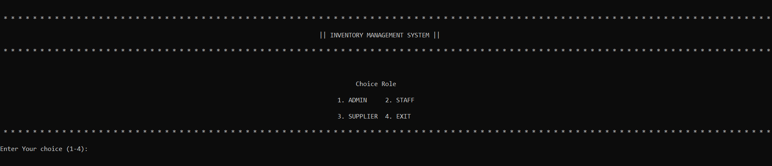
Figure 1.1 : Login Role :

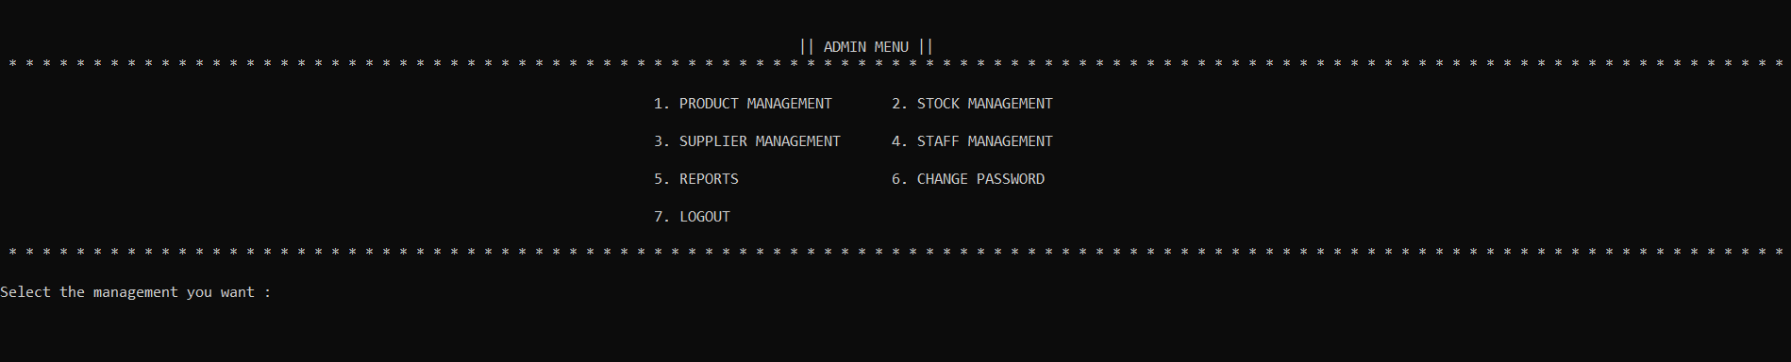
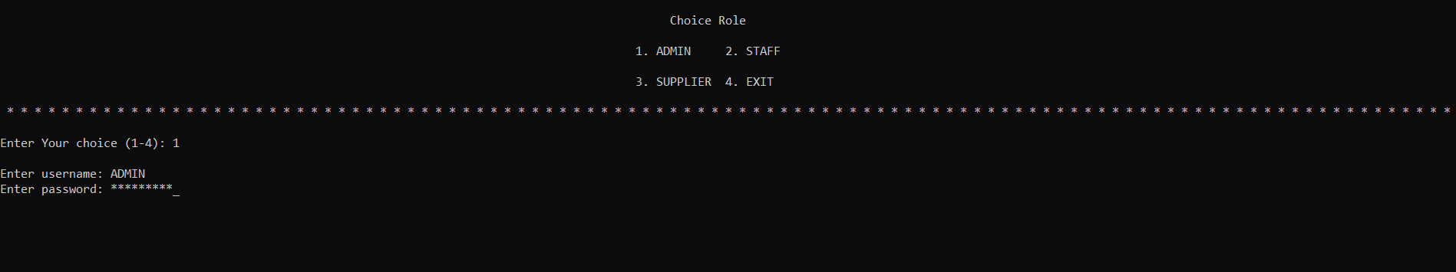
Figure 1.2 Admin Menu

Figure 1.3 Product Management :

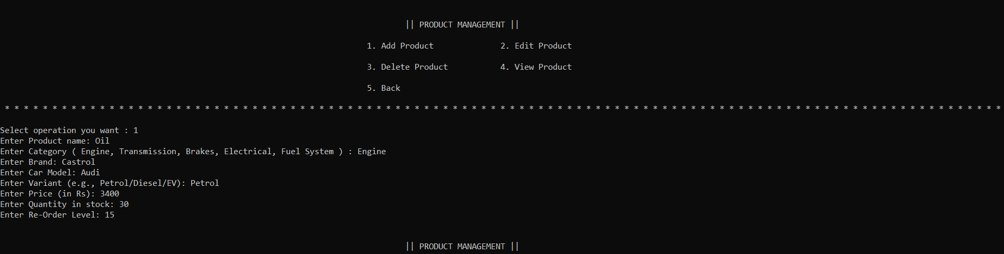
Figure 1.3.1 Add Product :
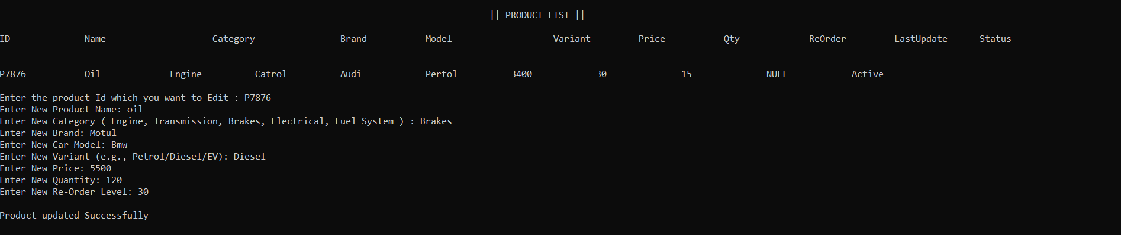
Figure 1.3.2 Edit Product :
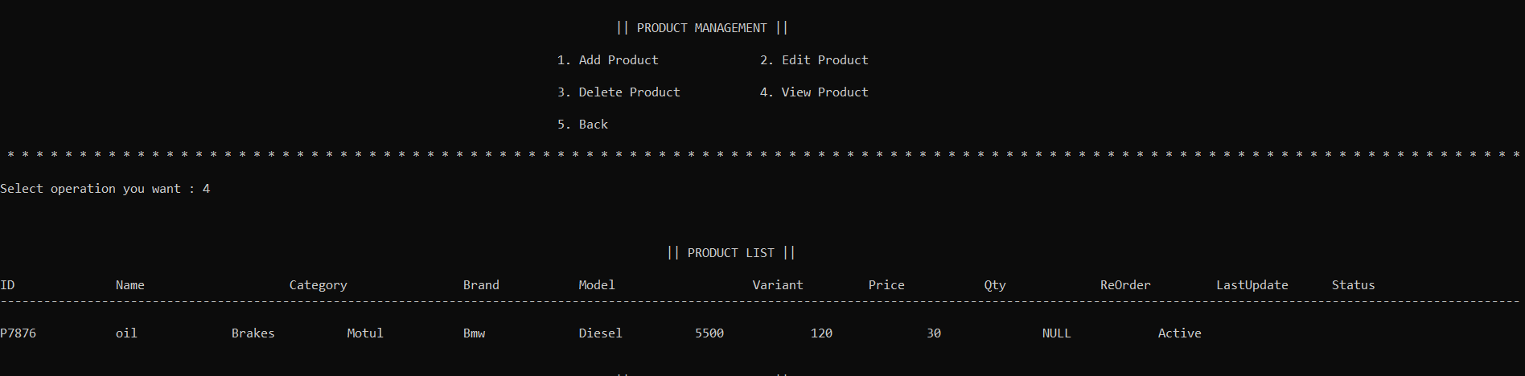

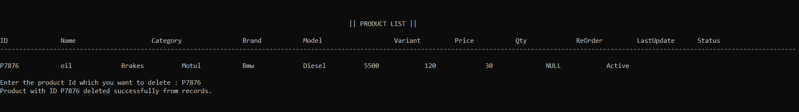
Figure 1.3.3 Delete Product

Figure 1.3.4 View Product :
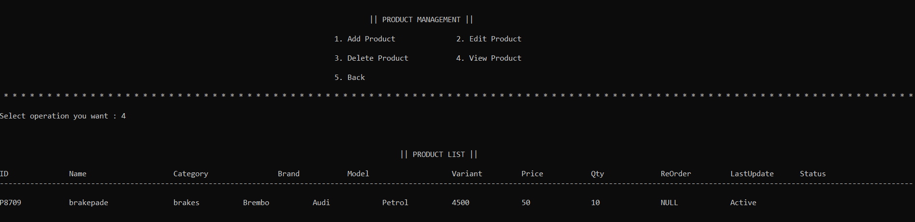

Figure 1.4 Stock Management :

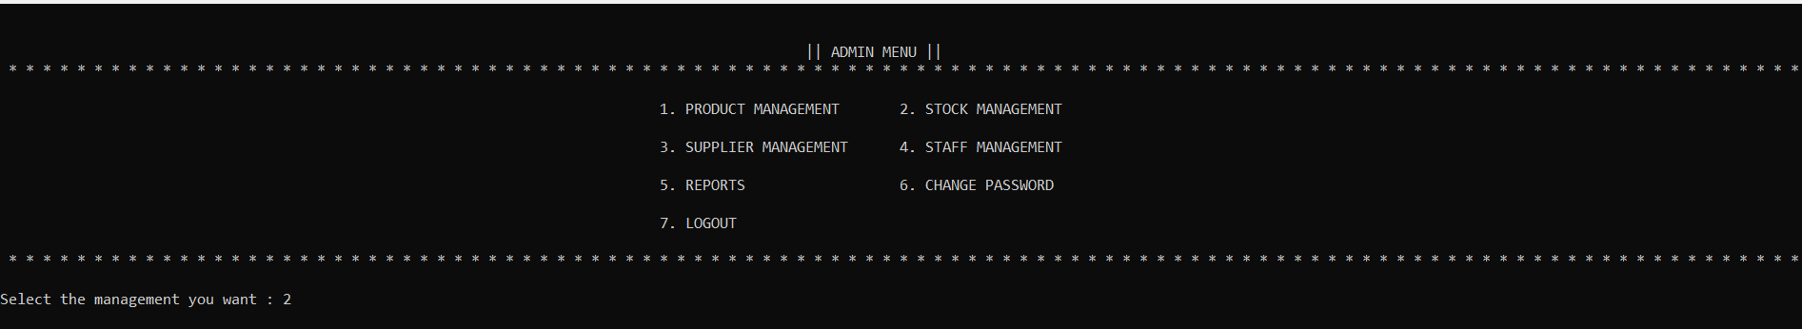

Figure 1.4.1 view Stock :
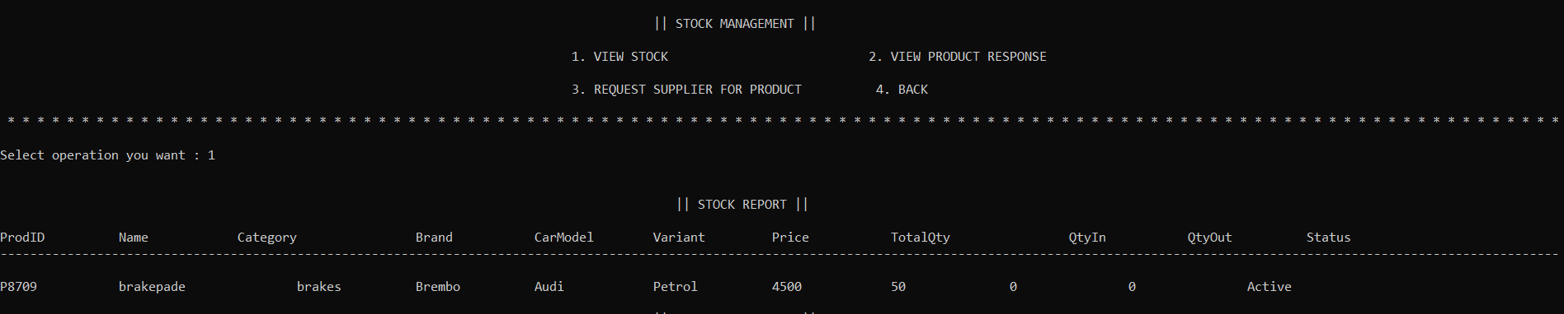

Figure 1.4.3 Request to supplier For product :

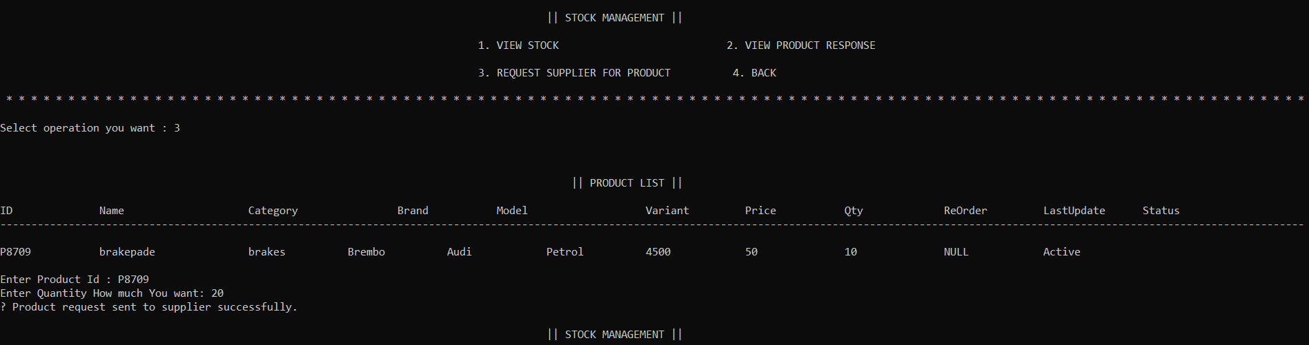

Figure 1.4.2 View Product Response :

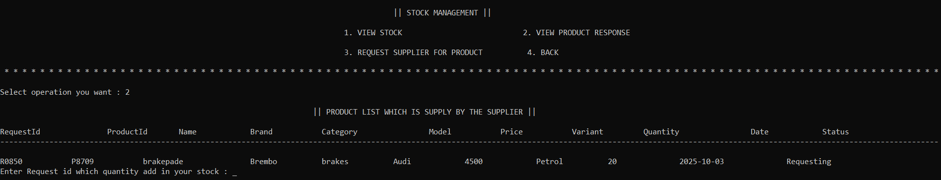

Figure 1.5 Supplier Management :

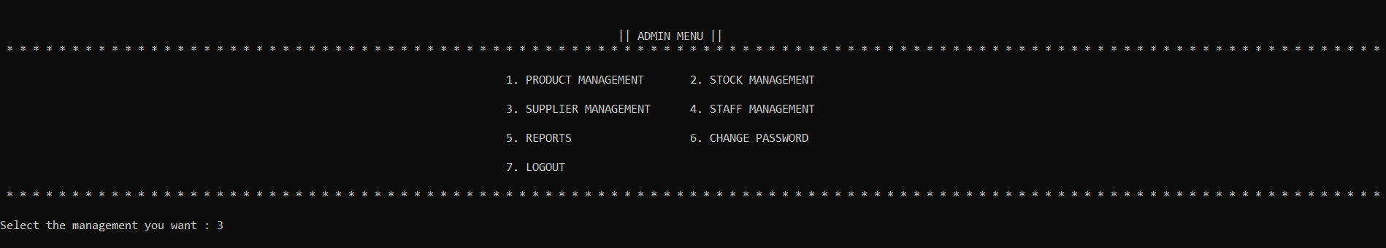

Figure 1.5.1 Add Supplier :

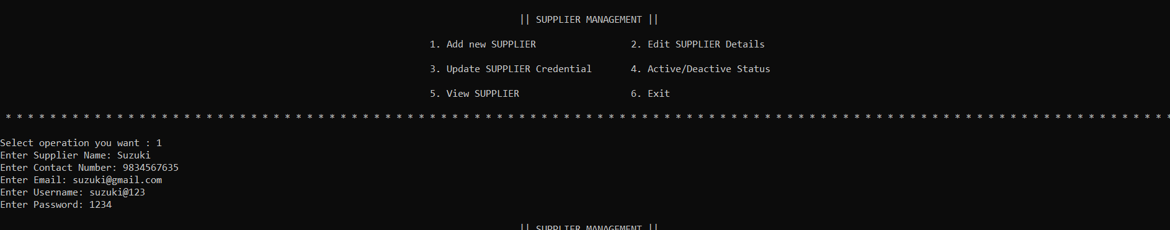

Figure 1.5.2 Edit Supplier :

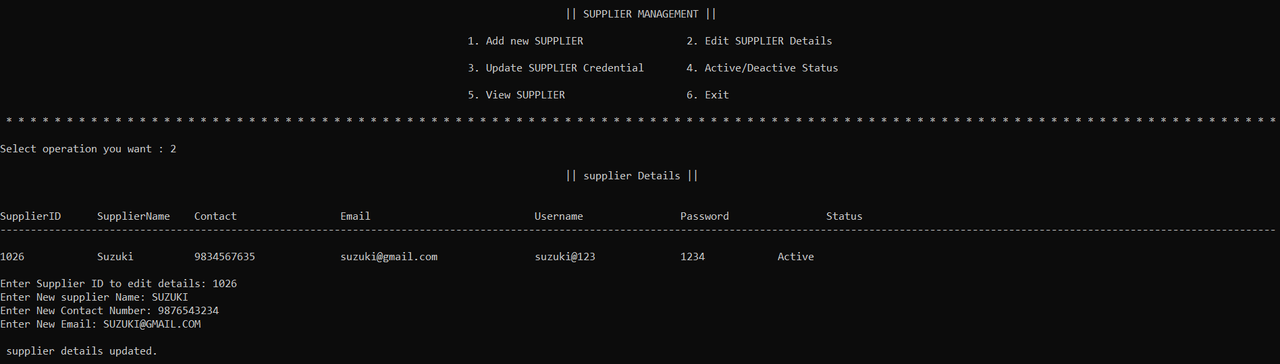

Figure 1.5.3 Edit Update Cridential :

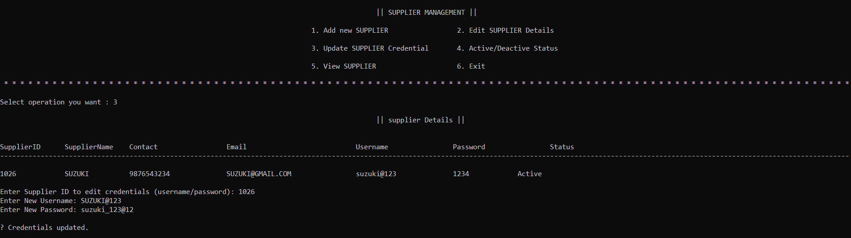

Figure 1.5.4 Edit Status :

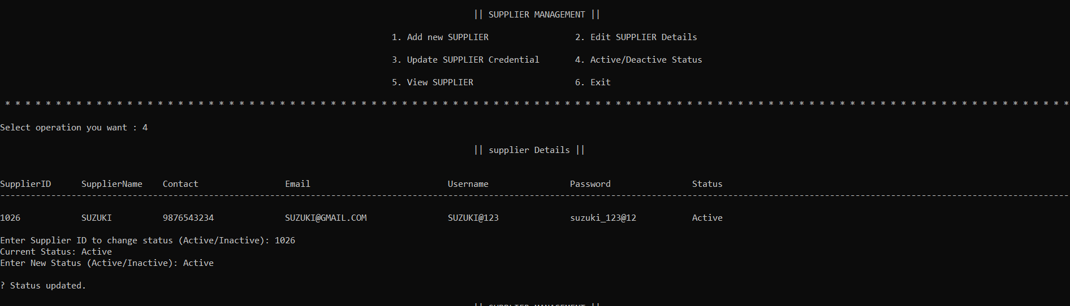

Figure 1.5.5 View Supplier :

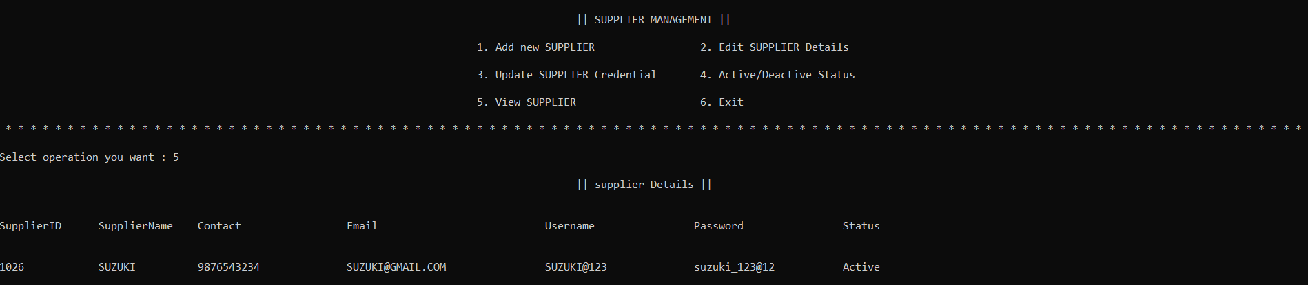

Figure 1.7 Reports :

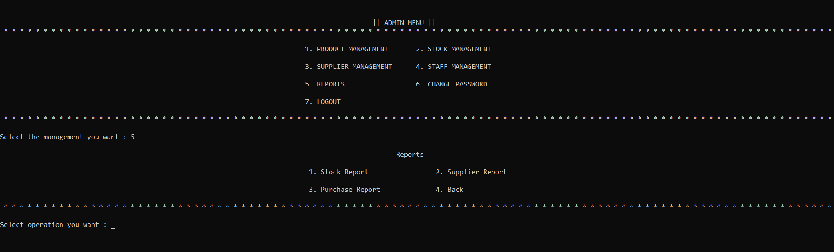

Figure 1.7.1 View Stock :

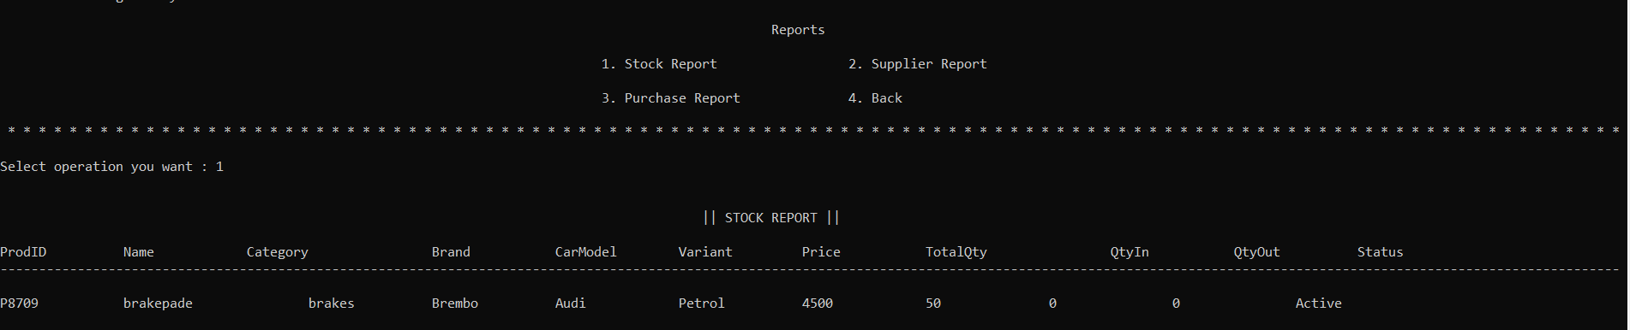

Figure 2.1 Staff Role :

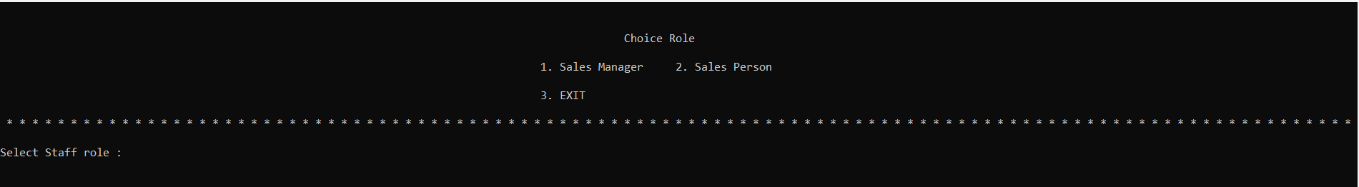
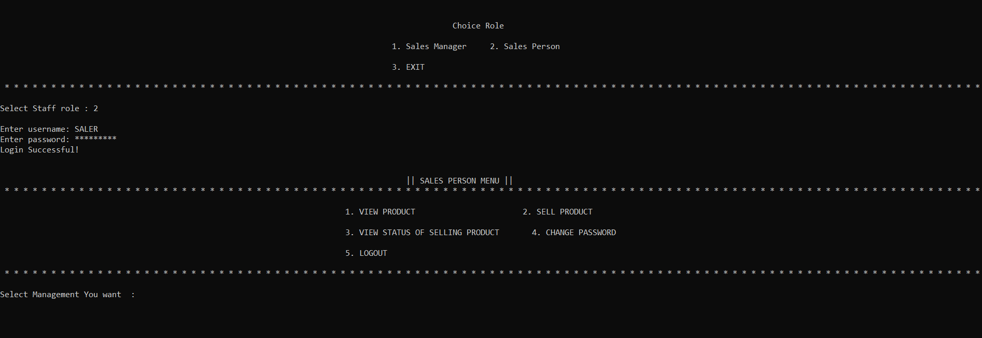

Figure 2.1.1 View Product :
  - Same as Figure 1.3.4

Figure 2.1.2 Sell Product :

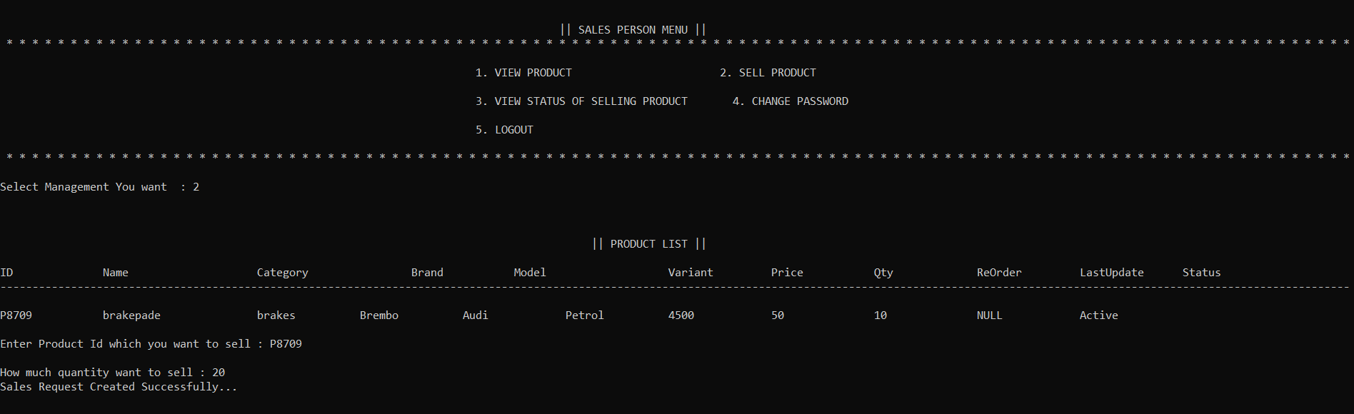

Figure 2.1.3 View Status Of selling Product :

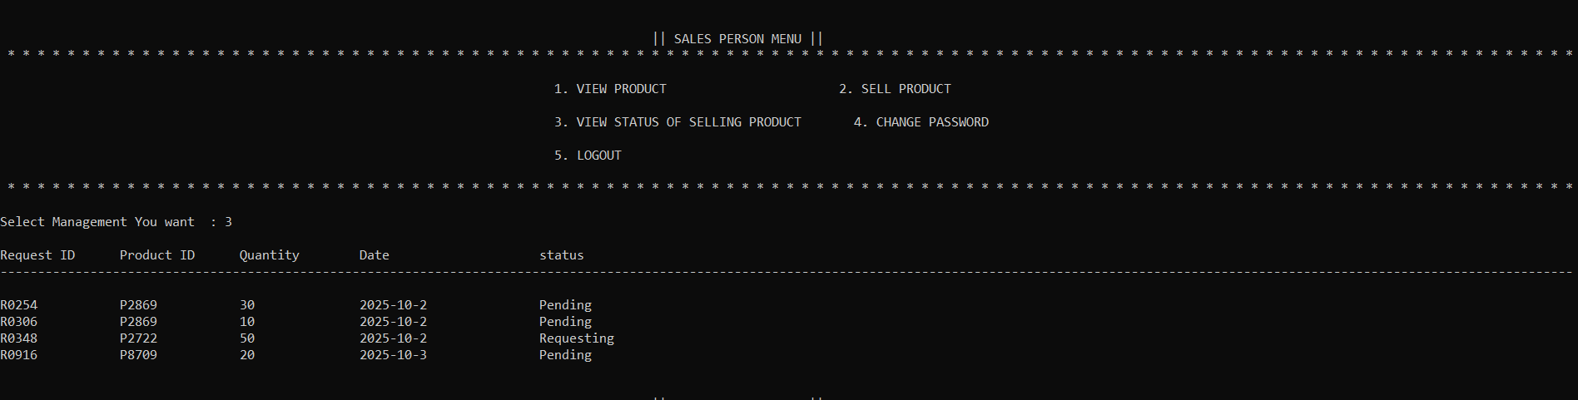

Figure 3.1 Manager Menu :

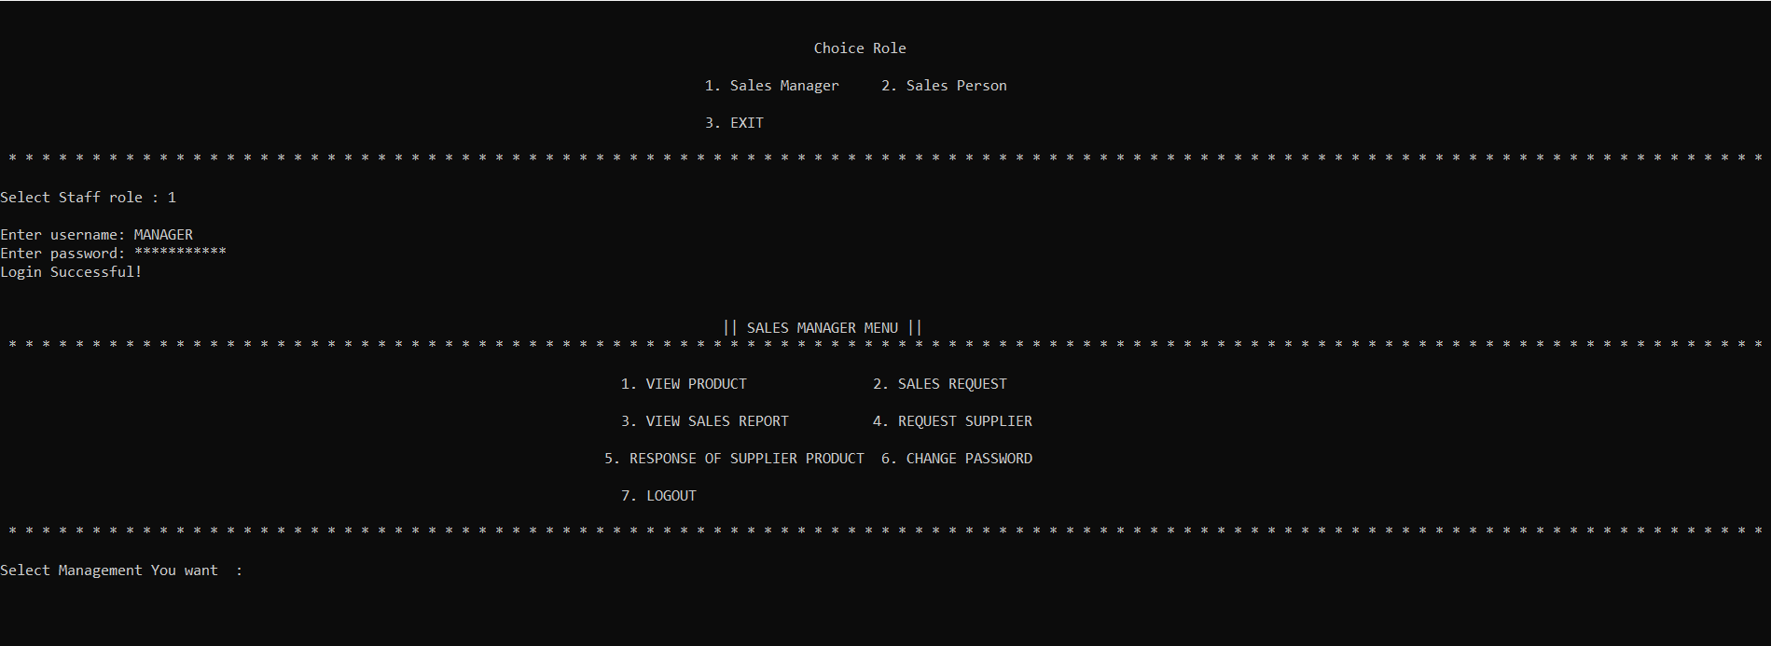

Figure 3.1.1 : View Product :
  - Same as Figuer 1.3.4

Figure 3.1.2 : Sales Request :

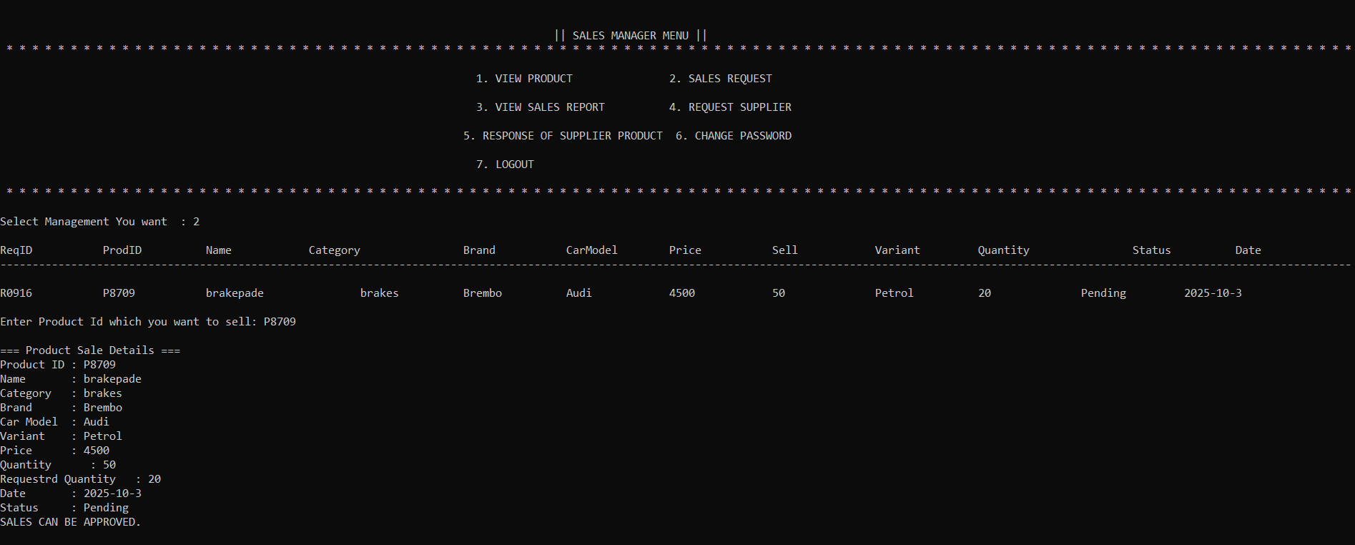

Figure 3.1.3 : View Sales Report :

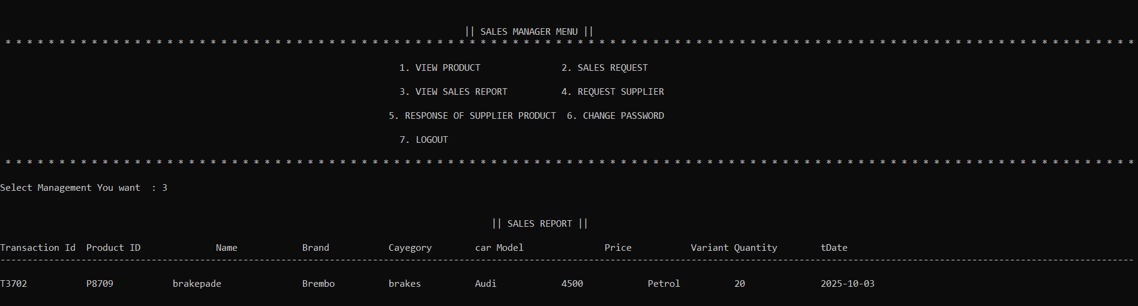

Figure 3.1.3 : Request To Supplier :
  - Same as figure 1.4.3

Figure 3.1.4 : Response of Supplier Product :
  - Same as figure 1.4.2

Figure 4.1.1 : View Request

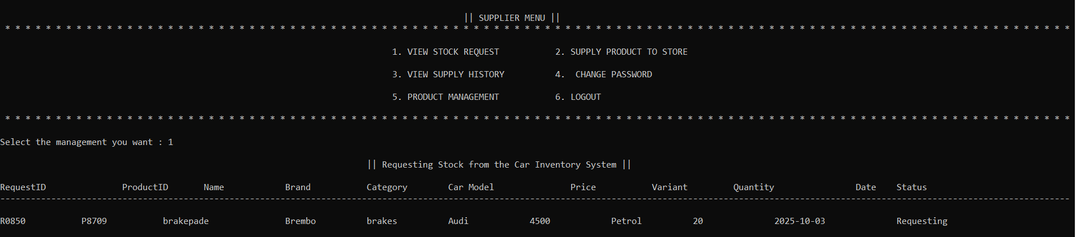

Figure 4.1.2 : Supply Product

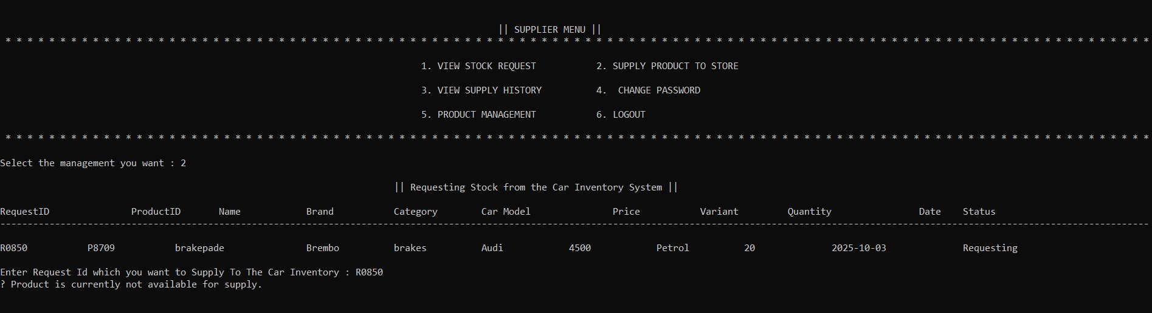

Figure 4.1.3 : View Supply History

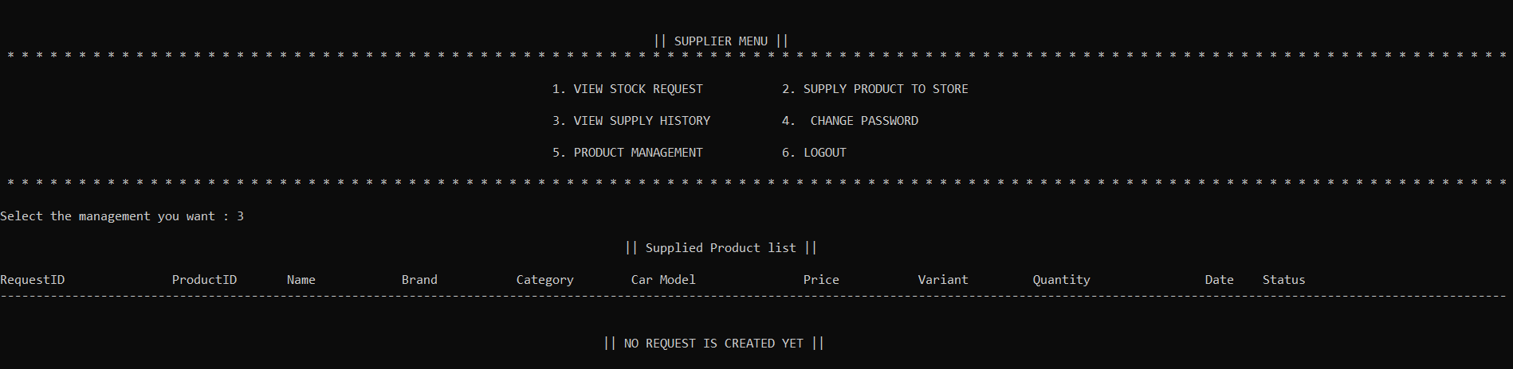

Figure 4.1.4 : Product Management

Figure 4.1.4.1 : Add Product :
  - Same as figure 1.3.1 ( Supplier_Products.txt )

Figure 4.1.4.2 : Edit Product :
  - Same as figure 1.3.2 ( Supplier_Products.txt )

Figure 4.1.4.3 : Delete Product :
  - Same as figure 1.3.3 ( Supplier_Products.txt )

Figure 4.1.4.4 : View Product :
- Same as figure 1.3.4 ( Supplier_Products.txt )

Test Cases

ADMIN MODULE TEST CASES

TC ID | Description | Steps | Input | Expected Result
TC_LOGIN_01 | Valid Admin Login | Enter correct username/password | ADMIN / admin@123 | Login Successful
TC_LOGIN_02 | Invalid Login | Enter wrong password | admin / wrong123 | Error message
TC_LOGIN_03 | Max Attempts | Enter wrong details 3 times | wrong creds | System locks for 30 sec

ADMIN MODULE TEST CASES

TC ID | Description | Steps | Input | Expected Result
TC_ADMIN_01 | Add Product | Go to Add → Save | Brake Pad | Product Added
TC_ADMIN_02 | Edit Product | Select product → Edit | P1001 | Updated
TC_ADMIN_03 | Delete Product | Select product → Delete | P1001 | Deleted
TC_ADMIN_04 | Add Supplier | Fill supplier form | Supplier Info | Added

STAFF MODULE TEST CASES

TC ID | Description | Steps | Input | Expected Result
TC_STAFF_01 | Create Sales Request | Enter product & qty | P1001 / 5 | Request Created
TC_STAFF_02 | Approve Sale | Approve request | R1001 | Approved
TC_STAFF_03 | Reject Sale | Reject request | R1001 | Rejected

SUPPLIER MODULE TEST CASES

TC ID | Description | Steps | Input | Expected Result
TC_SUPPLIER_01 | View Requests | Open stock requests | — | Requests displayed
TC_SUPPLIER_02 | Supply Product | Enter qty to supply | 10 | Supplied
TC_SUPPLIER_03 | Reject Supply | Insufficient stock | — | Rejected

System FlowChart

START

ADMIN

STAFF MANAGEMENT
PRODUCT
MANAGEMENT

STOCK MANAGEMENT

SALES PERSON

VIEW STOCK
VIEW PRODUCT
VIEW PRODUCT

SALES REQUEST
VIEW PRODUCT RESPONSE
REQUEST SUPPLIER FOR PRODUCT

STATUS OF SELLING PRODUCT

SALES MANAGER

VIEW PRODUCT

SUPPLIER
SALE PRODUCT

VIEW PRODUCT

PRODUCT MANAGEMENT

PRODUCT REQUEST
STOP
SUPPLIY PRODUCT
Proposed Enhancement

- Modular Code Design :

Improve overall system structure by breaking the application into independent and reusable modules such as Product Module, Stock Module, Supplier Module, Staff Module, and Report Module.
This approach increases code readability, simplifies debugging, and enhances maintainability and scalability for future.

Real-Time Stock Tracking System :

Implement live tracking of stock levels, supplied quantities, and sales activity.
Stock should automatically update whenever products are added, sold, or supplied, ensuring accurate and real-time inventory status.

Automated Notifications :

Introduce an automated alert system for:

Low stock warnings

Supplier response notifications

Successful supply or sales confirmations

Pending or rejected requests

Notifications can be delivered through email, SMS, or system pop-ups for faster communication and decision-making.

Online Product Request & Approval System :

Enable staff to request products digitally and wait for approval from the Sales Manager or Admin.
The system should track request progress (Pending / Approved / Rejected) and notify users instantly once updated.

Conclusion

The Inventory Management System provides an efficient and reliable solution for managing products, stock levels, suppliers, and sales activities within an organization. By automating manual tasks, the system minimizes human errors and ensures quick access to accurate information. The role-based modules for Admin, Staff, and Suppliers streamline operations and improve coordination between different departments. Features such as product management, stock tracking, supplier handling, and report generation enhance overall workflow and decision-making. With its simple, menu-driven interface and structured file-based approach, the system is easy to operate and maintain. Overall, this project significantly improves inventory handling efficiency, reduces operational delays, and serves as a strong foundation for integrating advanced features in the future..

References

- Inventory Management Fundamentals – Concepts related to stock control, supplier coordination, purchase management, and sales operations.
https://www.tutorialspoint.com/inventory-management.

- Inventory Control Techniques – Used to understand reorder levels, stock tracking, and supply-demand balancing.
https://www.geeksforgeeks.org/inventory-control-techniques

- File Handling in C++ – Referred for reading, writing, updating, and deleting product, staff, and supplier records.
https://www.geeksforgeeks.org/file-handling-cpp

